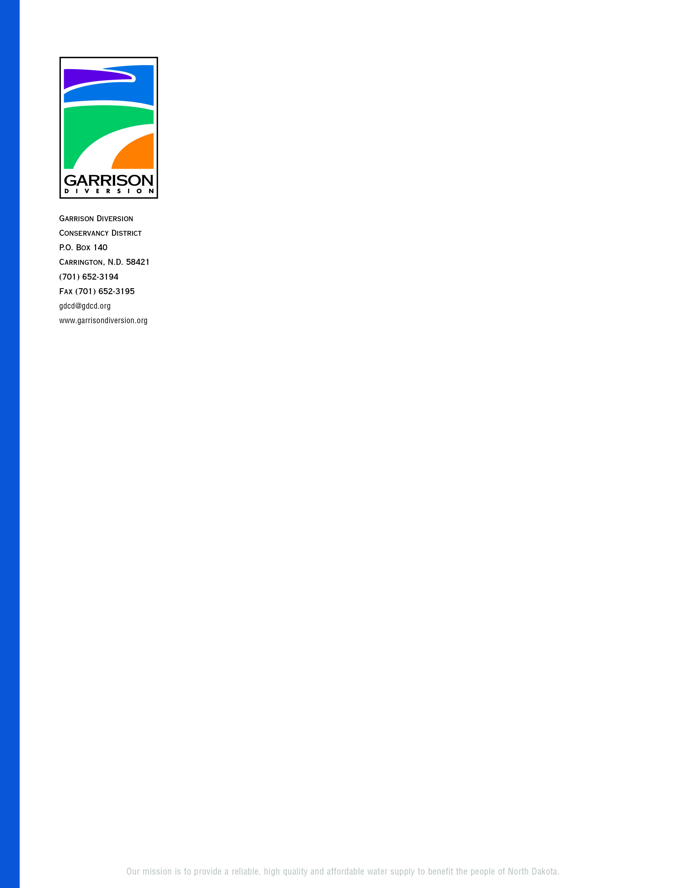

GARRISON DIVERSION CONSERVANCY DISTRICT
RED RIVER VALLEY COMMITTEE

NOTICE OF MEETING

DATE: Tuesday, December 12, 2023

TIME: Following adjournment of LAWA TAC meeting –
approximately 1:45 p.m.

PLACE: Advanced Engineering & Environmental Services
4050 Garden View Dr., Suite 200
Grand Forks, ND

Garrison Diversion Conservancy District’s Red River Valley Committee will meet as indicated above. Committee members are also encouraged to attend/participate in the LAWA Technical Advisory Committee meeting beginning at 9:30 a.m.

The purpose of the meeting(s) is to provide a Red River Valley Water Supply Project (RRVWSP) 2023 construction review, 2024 construction outlook, demand allocation report, pipeline hydraulic analysis, program cost update and to review and consider various task orders.

If you are unable to attend the meeting in person, you may join the meeting via Teams using the information provided below.

Join on your computer, mobile app or room device

Click here to join the meeting
Meeting ID: 295 118 799 977
Passcode: BtAzv2
Download Teams | Join on the web

Join with a video conferencing device
187186316@teams.bjn.vc
Video Conference ID: 113 883 382 7
Alternate VTC instructions

Or call in (audio only)
+1 701-566-0964 United States, Fargo
Phone Conference ID: 497 220 388#

DD/las

